Mini Project

Topic: "Movie Recommendation System: Machine Learning for Personalized Content"
Introduction:
We're building a movie recommendation system that uses machine learning to provide personalized content recommendations. To help us improve our system, we'd love to hear from you! Please take a few minutes to complete this survey and share your movie preferences and viewing habits with us. The purpose of this survey is to collect data on your movie preferences and viewing habits to help us train our machine learning model. Your responses will help us provide more accurate and personalized movie recommendations.

Data Collection Technique: Google Form

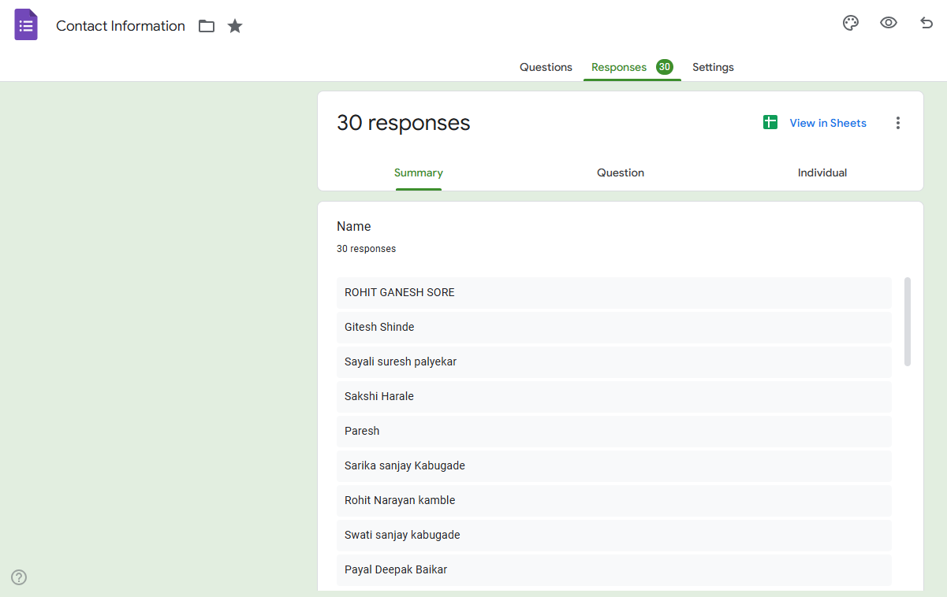

*Exploratory Data Analysis ( EDA ):
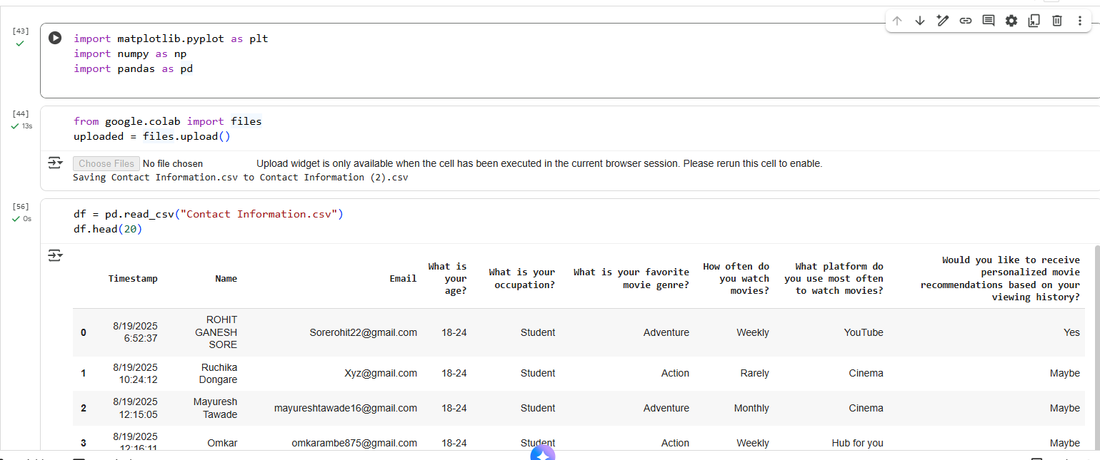
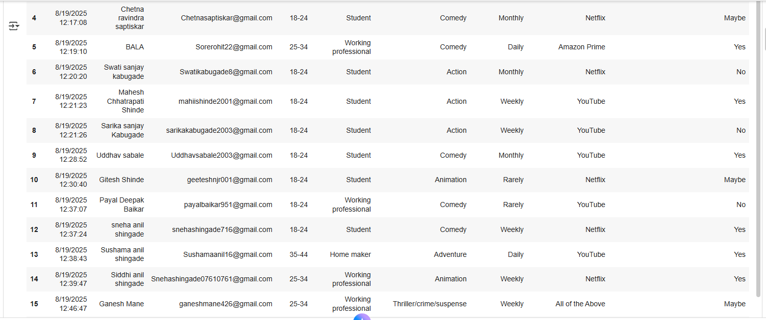
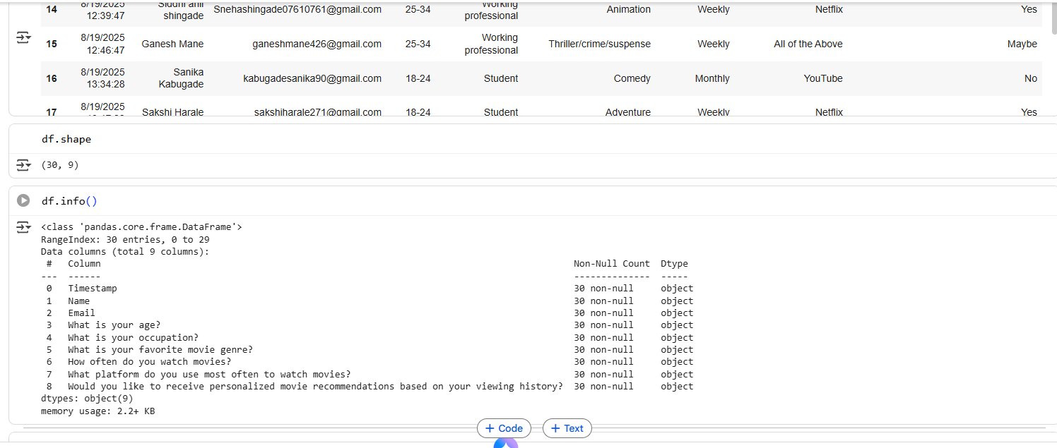
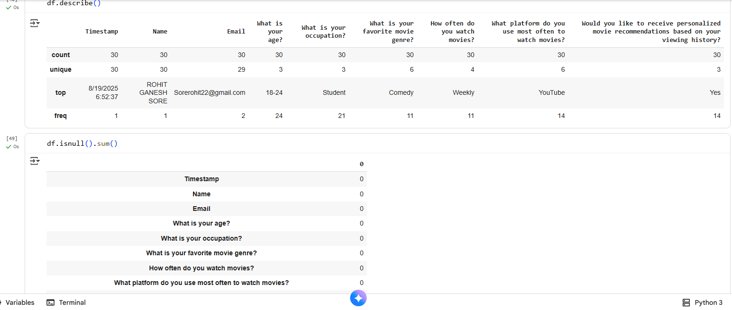
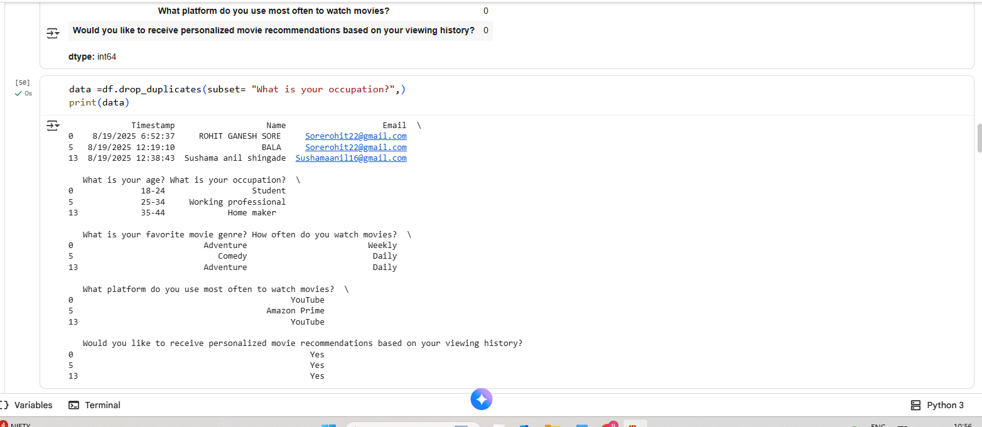
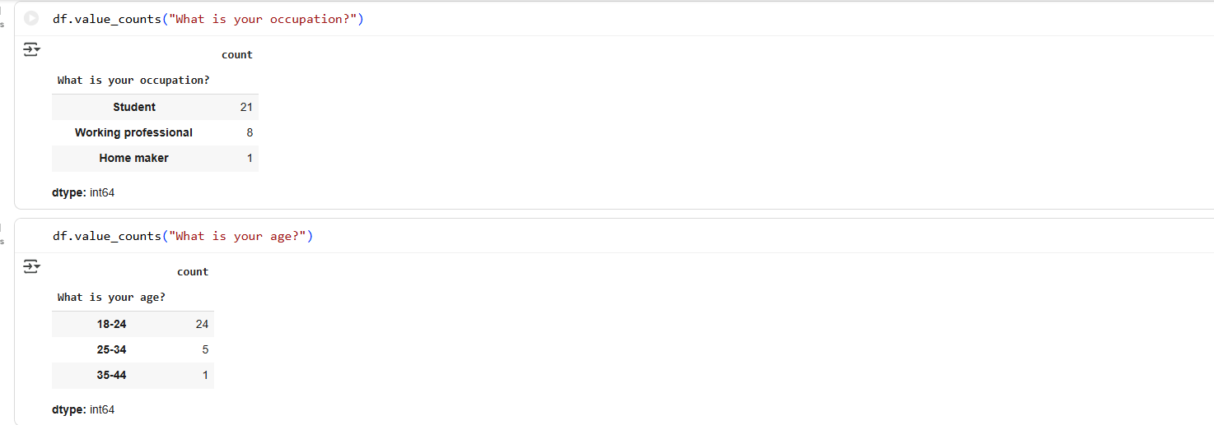

#Data Visualization:
# importing packages
import seaborn as sns
import matplotlib.pyplot as plt
sns.countplot(x='What platform do you use most often to watch movies?', data=df, )
plt.show()

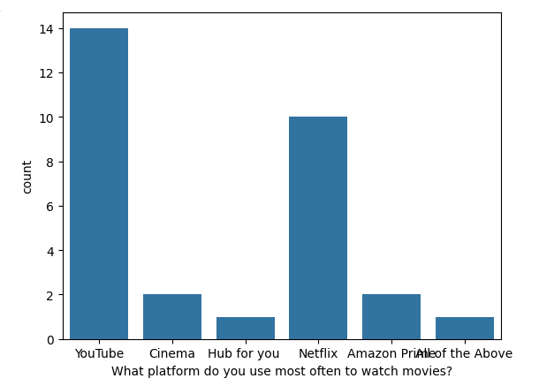

#Comparing 2 columns:

# importing packages
import seaborn as sns
import matplotlib.pyplot as plt
sns.scatterplot(x='How often do you watch movies?', y='What is your favorite movie genre?',hue='What is your age?', data=df, )
plt.legend(bbox_to_anchor=(1, 1), loc=2)
plt.show()

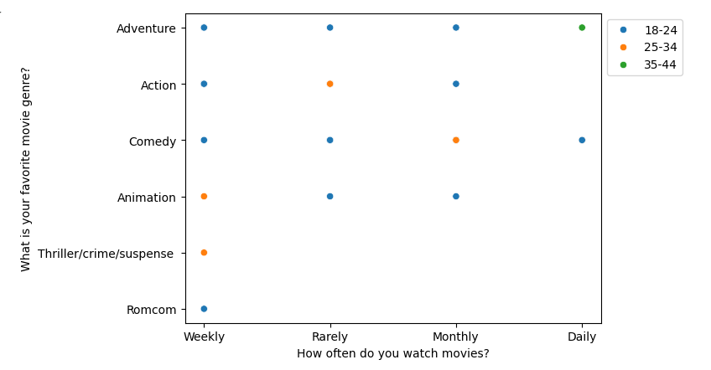

# importing packages
import seaborn as sns
import matplotlib.pyplot as plt
fig, axes = plt.subplots(2, 2, figsize=(10,10))
axes[0,0].set_title("How often do you watch movies?")
axes[0,0].hist(df['How often do you watch movies?'], bins=7)
axes[0,1].set_title("What is your favorite movie genre?")
axes[0,1].hist(df['What is your favorite movie genre?'], bins=5);
axes[1,0].set_title("What is your occupation?")
axes[1,0].hist(df['What is your occupation?'], bins=6);
axes[1,1].set_title("What is your occupation?")
axes[1,1].hist(df['What is your occupation?'], bins=6);

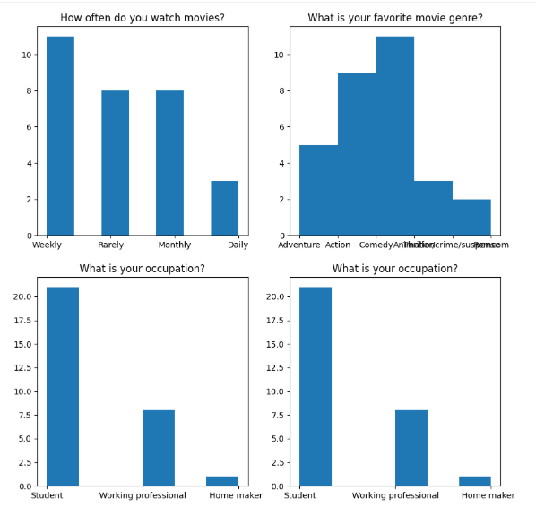

import seaborn as sns
import matplotlib.pyplot as plt

# Select categorical columns and convert to numeric codes
df_encoded = df.copy()
for col in ['What is your age?','Would you like to receive personalized movie recommendations based on your viewing history?']:
df_encoded[col] = df_encoded[col].astype('category').cat.codes

# Now drop 'Email' and plot
sns.pairplot(
df_encoded.drop(['Email'], axis=1),
hue='What is your favorite movie genre?',
height=2
)
plt.show()

